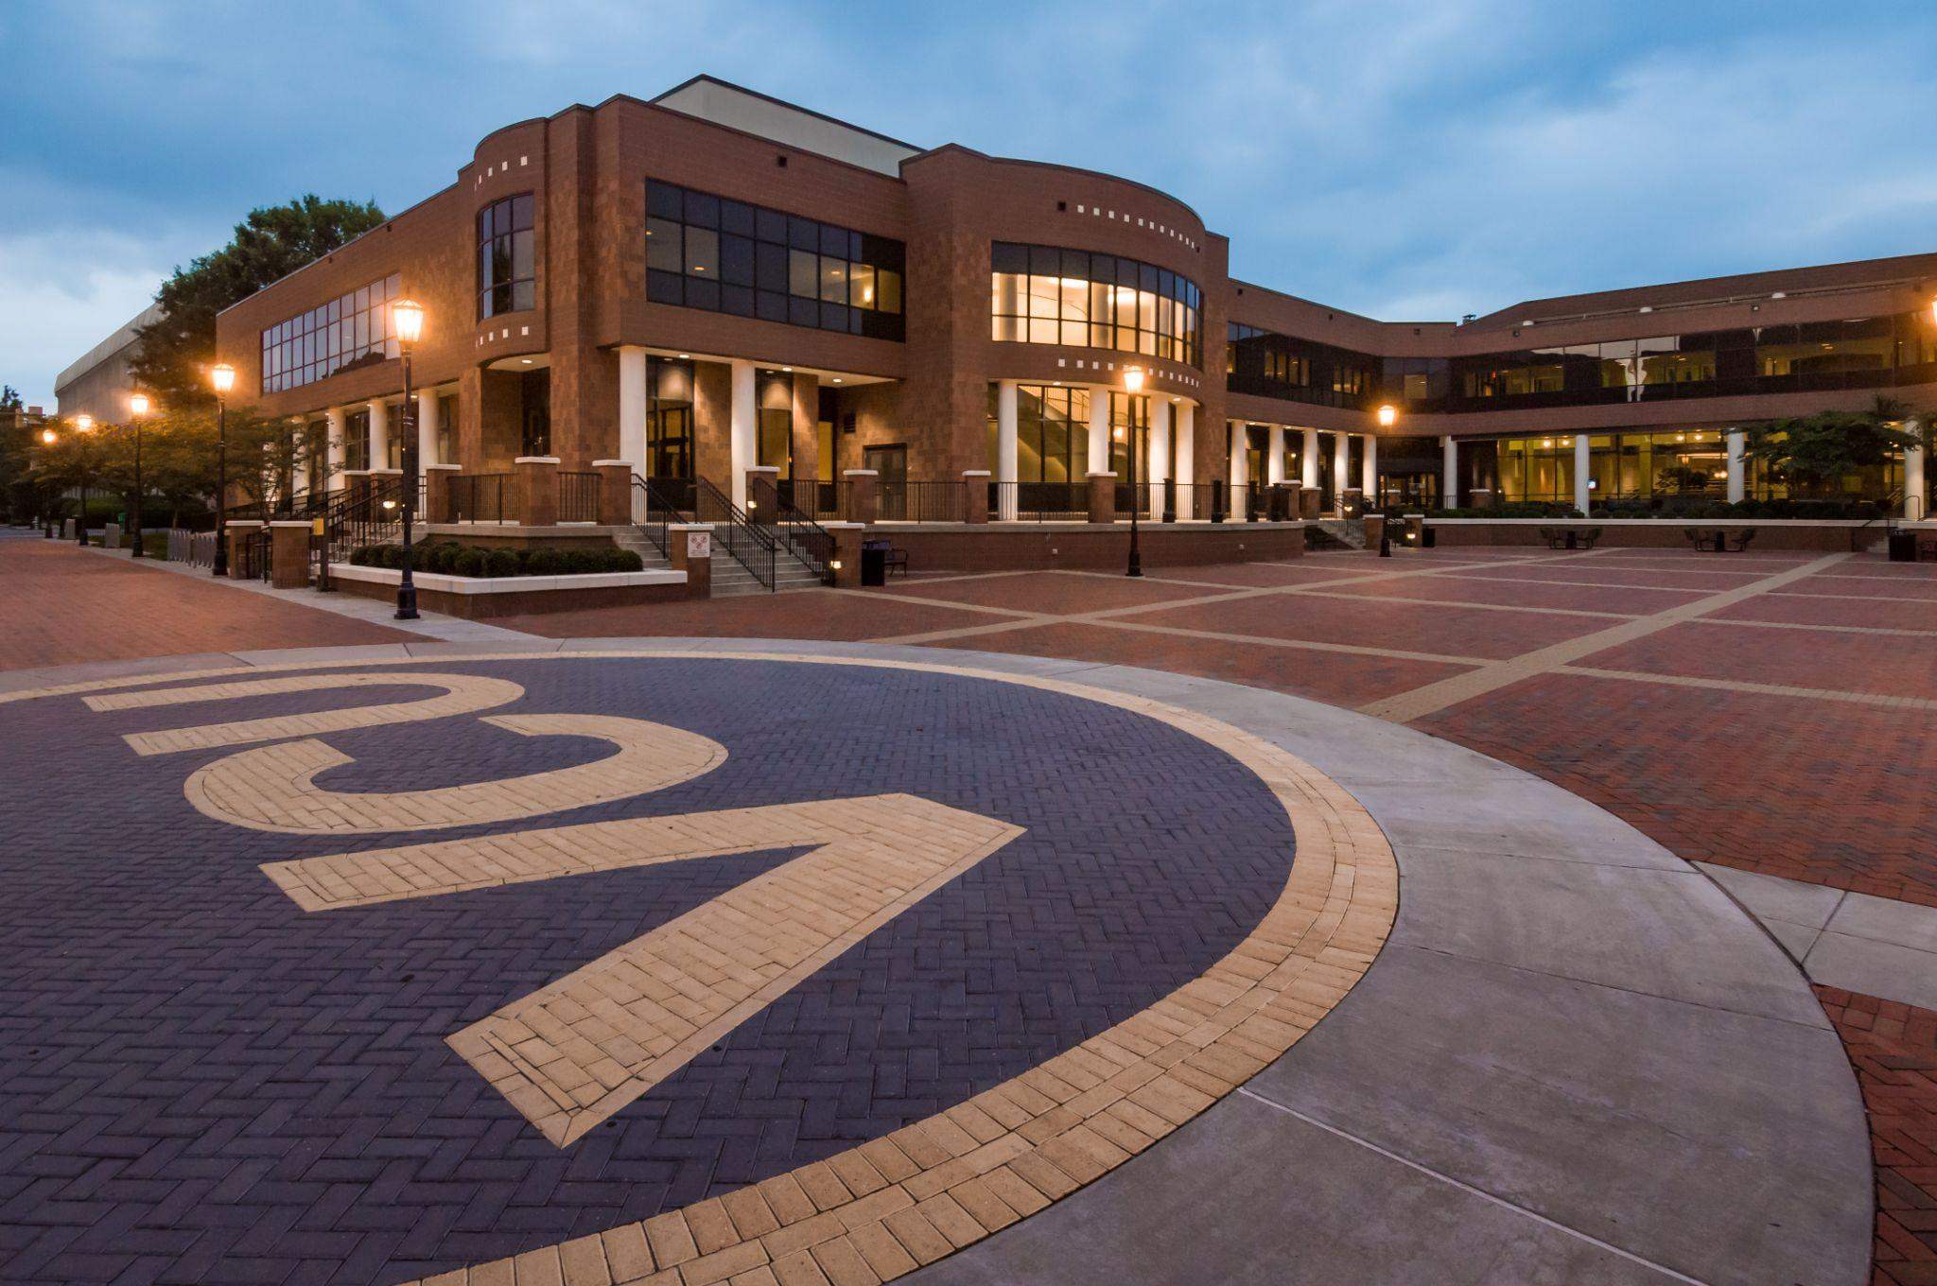

Virginia Commonwealth University

Campus Emergency Action Plan (CEAP)

2023

The Virginia Campus Emergency Action Plan (CEAP) will be reviewed annually and updated on an as needed basis. Modifications and/or revisions to the VCU CEAP are recorded in **Table 1** below.

**Table 1: Summary of Changes to VCU CEAP**

|  |  |
| --- | --- |
| Description of Change | Effective Date |
|  |  |
|  |  |
|  |  |

# Purpose

The purpose of the Virginia Commonwealth University Campus Emergency Action Plan (CEAP) is to inform the Virginia Commonwealth University (VCU) community of initial steps to take in the unlikely event of an emergency. The VCU CEAP will allow community members to ensure the continued preservation of their life safety during a multitude of hazards that have the potential to affect VCU. This plan contains generalized steps to take during the listed hazards, and are applicable throughout campus; however it should be noted that individual buildings across campus have more detailed EAP’s developed through the VCU Office of Safety & Risk Management that contain more specific steps to take for particular emergencies (evacuation routes, specific in building shelter locations, etc.). The VCU CEAP is to be used during an emergency as a frame of reference for those who either do not have building specific plans, are outside during an emergency, or are unable to access building specific plans. It should be noted that this plan is not intended to replace those procedures identified in building plans, rather to supplement them.. While this plan will not cover all potential hazards to the VCU community, it will cover response procedures for those that are more likely to occur.

# Scope

This plan is intended to comprehensively address the issue of safety and security within a VCU building during an emergency situation. It applies to all members of the VCU community within the Monroe Park Campus/MCV Campus Academic Buildings, including staff, faculty, students, and visitors. Emergency actions may be required at any time of day or night and may need to take place when there is no power and little or no visibility.

# Procedures

## Active Threat/Active Shooter

At the onset of an Active Threat/Active Shooter incident, contact VCU Police at (804) 828-1234. Do not place a phone call if you are at risk of being heard by the shooter. Wait until you are relatively safe to make the call. If it is unsafe to make a phone call, you can use the VCU Police LiveSafe App to text with our dispatchers. This app is free users can send texts, photos and video to VCUPD 24/7. If you see the shooter, try to remember a detailed description of their appearance, clothing, location and any weapons they are carrying to provide to police.

**Lockdown**

In instances where a campus lockdown is initiated, exterior doors on buildings with card access will be locked remotely from VCU Police Emergency Communications. If you are unsure whether or not your building has this function, please contact VCU Crime Prevention at (804) 828-1209, or the VCU Police Non-Emergency Line at (804) 828-1196.

In the event of a campus lockdown:

* Lock and barricade doors if possible. If you are in a room that cannot be secured or feels unsafe, consider seeking refuge in another nearby room that is more secure.
* Turn off lights and silence electronic devices, hide out of sight and away from doors and interior windows.
* Do not let anyone enter the room once it has been secured. Wait quietly until you receive further instructions from VCU Alert.

**Run-Hide-Fight**

While VCU Police are well trained, equipped, and capable of stopping threats to the VCU community, it is important to remember that safety is everyone’s responsibility.  During an active shooter event, you must be prepared to make the important decision to either run, hide, or fight if you find yourself in immediate danger.

**Run:** If you can safely escape the threat without putting yourself or others at risk, do so immediately. Know multiple evacuation routes and do not move towards the threat. Leave your belongings behind and exit the area as quickly as possible.

* Do not stop once you decide to run, and try to prevent others from entering unsafe areas as you evacuate.
* If you encounter any police officers, keep your hands in the air with fingers spread, follow their instructions and do not make any sudden movements or gestures. The first officers on scene are there to stop the threat, not to treat injuries or provide comfort. Keep moving and other first-responders will be in the area to assist you once you escape danger.

**Hide:** If unable to evacuate safely, follow the lockdown procedures outlined above to stay safe until the situation is resolved. Make smart choices about where to seek refuge. Ideally you will hide in a place that is out of sight, can be secured or locked, and provides some cover or concealment from the shooter.

**Fight:** As a last resort, if the shooter is an immediate threat to yourself you must take physical action to protect your life and stop the threat. Act with aggression and speed; attack the shooter at close range until the threat is stopped. Consider fighting as a group and using improvised weapons such as chairs and fire extinguishers.

## Bomb Threat

**If A Threat is Made in Person**

Remain calm. If possible, move away from the area of the suspect and immediately notify VCU Police (804-828-1234) either by phone, or, if more practical, over the LiveSafe App. If making the notification to police via a phone call, avoid using a cell phone if possible. While on the phone with police:

* Share as much suspect information as possible, including a description of the individual, anything they may have been holding, or any statements they made.
* Listen to their directions on how to proceed further, i.e. evacuation, shelter in place, etc.

If circumstances dictate and you need to evacuate, do so discreetly, and notify others to do the same.

**If A Threat is Made over the Phone**

If you receive a phone call from a person suspected of planting a bomb or stating there is a bomb, take the following steps and collect the following information:

* Keep the caller on the phone as long as possible. Do not hang up.
* Listen carefully, be polite, and show interest.
* Try to keep the caller talking to learn more information.
* If possible, have someone in your area call VCU Police at (804) 828-1234 while you speak to the caller, or, if possible, send a live-safe alert to VCU Police.
* Ask the caller for the following information. Ensure you copy the exact wording the caller uses.

* + 1. Where is the bomb located (building, floor, room, etc)?
    2. When will it go off?
    3. What does it look like?
    4. What kind of bomb is it?
    5. What will make it explode?
    6. Did you place the bomb?
    7. Why was the bomb placed?
    8. What is your name?

Estimate the following information about the caller. Utilize the table if necessary.

1. Where is the caller located (based on background noises, level of noise, etc.)?
2. Estimate age iii. Is the voice familiar? If so, who does it sound like?

**Caller’s Voice**

* Female
* Male
* Accent ___________
* Angry
* Calm
* Clearing throat
* Coughing
* Crackling Voice
* Crying
* Deep
* Deep breathing
* Disguised
* Distinct
* Excited
* Laughter
* Lisp
* Loud
* Nasal
* Normal
* Ragged
* Rapid
* Raspy
* Slow
* Slurred
* Soft

**Background Sounds**

* Animal noises
* House noises
* Kitchen noises
* Street noises
* Booth
* PA system
* Conversation
* Music
* Motor
* Clear
* Static
* Office Machinery
* Factory Machinery
* Local
* Long distance

**Threat Language**

* Incoherent
* Message read
* Taped message
* Irrational
* Profane
* Well-spoken

1. If you are in possession of a two-way radio, ensure it is turned off.
2. Do not attempt to locate, or tamper with any suspicious devices/packages.
3. Do not share that there is a bomb threat in progress so as not to cause panic. Ensure the conversation remains between you, the caller, and law enforcement. Law Enforcement will make notifications if and when the threat is deemed credible.

## Fire

When responding to either a fire, or audible fire alarm, the steps you take should remain the same. Quickly begin to proceed to the nearest exit, and close all doors while exiting (this may help to contain smoke and fire); remember, the nearest exit may not always be the main entrance. When outside the building, gather at a predetermined assembly point and await further instruction from first responders or safety personnel.

If you are unable to evacuate for any reason during a fire emergency, you may choose to “shelter in place,” this may be a better option in a building with a full sprinkler system. Choose a room with a fire resistant door and an exterior window. Regardless if you evacuate, or shelter in place, make sure to notify VCU Police (804-828-1234) of the emergency.

If possible, review your building's facility specific EAP maintained by either the buildings manager, or VCU Safety & Risk Management to familiarize yourself with the building's predetermined assembly points in the event of an evacuation.

## Tornado

In the event of a tornado or tornado warning issued by the National Weather Service, a VCU Alert will be sent out to the campus, including text, alert panels, email, sirens, and Live Safe App notifications to inform the community of the hazard. In the event you receive tornado warning, or observe an active tornado, the following steps should be taken:

Move immediately to a ground floor, or basement shelter location. If your building does not have a basement, relocate to the center of the structure, as far away from windows, and doors with glass panes as possible, additionally, you can sit or crouch within an inner hallway, bathroom, or room of the structure. If your building has a facility specific EAP, and you have access to that document, relocate to your building's pre-determined sheltering area for the duration of the Tornado/Tornado Warning. If you are outside, seek shelter inside the nearest building on the ground floor or basement.

Avoid using elevators, and do not leave the safe location until emergency personnel, or the VCU Alert System, gives an “all clear”. Following the tornado, ensure you avoid broken glass, debris and any unstable structures in your area. If there is noticeable damage to your building, notify your building manager immediately.

## Medical Emergency

During a medical emergency, contact VCU Police at (804) 828-1234 or Richmond Police at 911 for Emergency Medical Service (EMS/Ambulance). When on the phone with emergency services, be sure to provide your name, exact location (building address, room number (if inside), and any key information about the individual in need of medical attention. Additionally, advise the emergency operator where EMS can be met, or enter the building (if the building is a secured facility). Remain with the injured person until VCU Police or EMS arrives, and if possible, have an additional individual meet EMS near the roadway to escort them to the injured party. Remain calm, and reassure the injured person (even if they appear unconscious) that help is on the way.

Avoid rendering first aid or medical care to the injured individual unless you are trained to do so.

## Suspicious Person

If you notice a suspicious person within your facility, notify VCU Police (804-828-1234) or Richmond Police at 911. Provide authorities with a description of where the person(s) was last observed, and any behaviors you noticed. Alert others on your floor or area, and remember if you “see something, say something”.

Some behaviors that may be deemed suspicious are:

* Going door to door, office to office.
* Loitering in hallways or commons areas.
* Entering private offices unescorted.
* Offering items for sale in buildings.
* Entering secure areas that they should not.
* Asking for an unknown individual or department.
* Asking for money.
* Leaving packages and/or bags unattended.
* Anyone who does not appear to belong in the area.

## Earthquake

During an earthquake, if indoors, immediately drop to the ground; take cover by getting under heavy furniture, such as a desk, table or bench until the shaking stops. If outside, stay clear of buildings, power lines, overpasses and elevated expressways, due to possible falling debris.

Aftershocks are possible for several weeks following an Earthquake, which can increase the risk of further structural damage in the affected area. If, following the earthquake you notice any suspicious smells or odors of gas, contact VCU Police immediately at (804) 828-1234. If there is noticeable damage to your building, notify your building manager immediately.

## 

## IV. Accountability

During and after any emergency, it is important to maintain accountability for all the occupants of a facility. If possible, maintain a list of those within your building to ensure everyone can be marked safe from an incident; this list can also aid first responders in casualty tracking and/or search and rescue efforts in the event an incident warrants such actions.

If applicable, refer to your building's facility specific EAP for your facility’s evacuation coordinators information, as well as information on pre-designated assembly points that will aid in maintaining accountability of personnel during and after an emergency.